
University of Gondar
INSTITUTION OF INFORMATICS
DEPARTMENT OF COMPUTER SCIENCE
DATABASE ASSIGNMENT
GYM MANAMGMENT STYSTEM
GROUP MEMBERS ID NO
- DANEIL ABRARAW GUR/01841/16
- TEWODROS KASSAHUN GUR/01343/16
- TAMRAT BEYENE GUR/01330/16
- WORKYE GEBRE GUR/02973/15
- GENETE ZEWUDU GUR/01479/16
- MESERET G/MARIAM GUR/02811/16
- MAREGU ADEBABAY
- AYUB ABDULJELIL GUR/01008/16
- MIHIRET GISIMIE GUR/02429/16
- SELEMON YENENEH GUR/01361/16

Submitted to : Mr REDAT
Submission date :Mar 3, 2017 E.C

Chapter 1: Introduction
Background: This Gym Management System aims to streamline the management of gym operations, including member registration, class scheduling, trainer assignments, and billing. The system will enhance efficiency and improve the overall member experience.
The objective of using a Gym Management System at a gym is to streamline and automate various administrative and operational tasks. This management system is going to solve or make it easy the following objectives:

1. Efficient Member Management: Easily register and manage member information, track attendance, and monitor membership status.
2. Class Scheduling: Organize and manage class schedules, allowing members to book and attend classes seamlessly.
3. Trainer Assignments: Assign trainers to classes and personal training sessions, ensuring optimal use of resources.
4. Billing and Payments: Automate billing processes, track payments, and manage financial records accurately.
5. Inventory Management: Keep track of gym equipment and supplies, ensuring timely maintenance and replacement.
6. Reporting and Analytic s: Generate reports on various aspects of gym operations, such as member attendance, financial performance, and class popularity, to make informed decisions.
7. Enhanced Member Experience: Provide members with a user-friendly platform to manage their memberships, book classes, and access gym information.

By achieving these objectives, a Gym Management System helps improve efficiency, reduce administrative workload, and enhance the overall member experience.

Statement of the Problem: Managing gym operations manually can be time-consuming and prone to errors. The proposed system will automate these processes, reducing administrative workload and improving accuracy.

Objectives:
General Objective: To develop a comprehensive Gym Management System that automates and optimizes gym operations.
Specific Objectives:
- To create a database for storing member information, class schedules, and trainer details.
- To implement features for member registration, class booking, and billing.
- To ensure data integrity and security.

Methodology:
- Data Collection Technique: Surveys and interviews with gym staff and members to gather requirements.
Also by inspection ,and gathering information in different websites which works on gymnasium
- Database Modeling Approach: Entity-Relationship (ER) model to design the database structure.
- Hardware and Software Requirements: A server with a relational database management system (RDBMS), development tools like SQL, and a web server for the application.

Like its mentioned above To develop a Gym Management System, we will need both software and hardware components. Here's a breakdown:
Software Requirements
1. Database Management System (DBMS):
- MySQL, PostgreSQL, or Microsoft SQL Server for managing the database.(in this project we will use MYSQL)
2. Development Tools:
- Integrated Development Environment (IDE) like Visual Studio Code, Eclipse, or ,dbms
But we are concentrating the database side so we will use dbms development Environment.
- Programming languages such as Java, Python, or PHP for back-end development.
- HTML, CSS, and JavaScript for front end development.
3. Web Server:
- Apache or Nginx to host the web application.
4. Operating System:
- Windows, macOS, or Linux, depending on our project we prefer windows
5. Version Control System:
- Git for version control and collaboration.
6. Frameworks and Libraries:
- Back end frameworks like Django (Python), Spring (Java), or Laravel (PHP).
- Front end libraries like React, Angular.

Hardware Requirements
1. Server:
- A server with sufficient processing power, memory, and storage to host the database and web application. For small to medium-sized gyms, a server with the following specifications should suffice:
- Processor: Quad-core or higher
- RAM: 8GB or higher
- Storage: 500GB SSD or higher
2. Client Devices:
- Computers, tablets, or smartphones for gym staff and members to access the system. Ensure these devices have internet connectivity and modern web browsers.
3. Network Infrastructure:
- Reliable internet connection and networking equipment (routers, switches) to ensure smooth communication between client devices and the server.
4. Backup Solutions:
- External hard drives or cloud storage services for regular backups of the database and application data.

By meeting these software and hardware requirements, you'll be well-equipped to develop and deploy a robust Gym Management System.

Chapter 2: Database Design
Overview: The database will be designed using the ER model to ensure efficient data storage and retrieval.

Business Rules/Requirements:
- Each member must have a unique ID.
- Classes can have multiple members, but each member can only book one class at a time.
- Trainers can be assigned to multiple classes.

Building Blocks of the Database:
- Tables: Members, Classes, Trainers, Bookings, Payments.
- Fields: MemberID, Name, ContactInfo, ClassID, TrainerID, BookingID, PaymentID, etc.
- Primary and Foreign Keys: Member-ID (primary key in Members table), Class-ID (primary key in Classes table), Trainer-ID (primary key in Trainers table), Booking-ID (primary key in Bookings table), Payment-ID (primary key in Payments table), etc.
- Relationships: Members to Bookings (one-to-many), Classes to Bookings (one-to-many), Trainers to Classes (one-to-many).

ER Diagram:

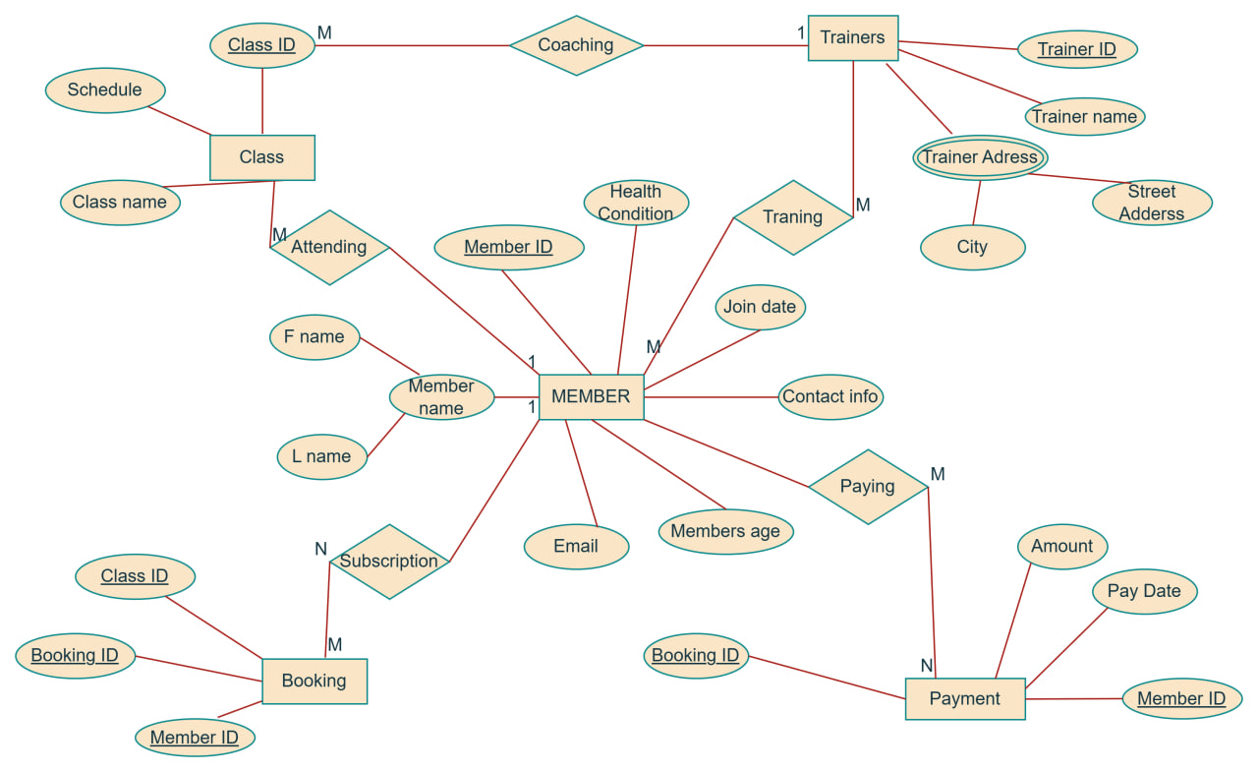

Relational Model: Mapping the ER model to relational tables with primary and foreign keys.

Members Table:
- MemberID (Primary Key)
- Name
- ContactInfo
-age
- Join date
- Heath condition
- Email
Trainers Table:
- TrainerID (Primary Key)
- TrainerName
- trainerAddress
Bookings Table:
- Booking-ID (Primary Key)
- MemberID (Foreign Key)
- Class-ID (Foreign Key)
Payments Table:
- Payment-ID (Primary Key)
- MemberID (Foreign Key)
- Amount
- PaymentDate
Classes Table:
- Class ID (Primary Key)
- ClassName
- Schedule

normalization
First Normal Form (1NF)
Ensure that each table has a primary key and that each column contains atomic values (no repeating groups or arrays).

Members Table:
- Member ID (Primary Key)
- Name
- Contact Info
- age
Member ID | name | Contact info | age
1 | Henok Aserat | henok…@gmail,com | 21
2 | Aster aweke | Astu…..@gmail.com | 34
3 | Roble teshome | robiy….@gmail.com | 28
4 | Mekonen gebru | Meku….@gmail.com | 41
5 | Kaleab tebkew | Kaleab……..@gmail.com | 16

Classes Table:
- Class ID (Primary Key)
- ClassName
- Schedule
Class id | Class name | schedule
101 | yoga | 2:00am
102 | Weight lifting | 3:00am
103 | Pre-workout | 4:00am
104 | Advanced workout | 6:00am

Trainers Table:
- TrainerID (Primary Key)
- TrainerName
- trainer address
trainerID | Trainer name | Trainer address
011 | alemu | Gonder_maraki
012 | alex | Gonder_maraki
013 | selam | Gonder_ azezo
014 | habtu | Gonder_piazza
015 | biruk | Gonder_maraki

Bookings Table:
- Booking-ID (Primary Key)
- MemberID (Foreign Key)
- Class-ID (Foreign Key)
Booking ID | memberID | classID
06 | 1 | 101
07 | 2 | 104
08 | 3 | 101
09 | 4 | 103
010 | 5 | 104

Payments Table:
- Payment-ID (Primary Key)
- MemberID (Foreign Key)
- Amount
- PaymentDate
member id | Payment id | ammount | paymentdate
1 | 06 | 250 | 02/07/2017
2 | 07 | 250 | 04/07/2017
3 | 08 | 250 | 01/07/2017
4 | 09 | 250 | 02/07/2017
5 | 010 | 250 | 05/07/2017

Second Normal Form (2NF)
Ensure that all non-key attributes are fully functional dependent on the primary key. This means removing partial dependencies.
In our case, all tables are already in 2NF because each non-key attribute is fully dependent on the primary key. except the trainer table and member tables in those table and there is trainers address ,and also members first and last name at the same tuples this makes contradictory on retrieve information about their city and neighborhood and also there names so by this case those particular tables are no in 2nf
Lets make it 2nf our tabel

We are going to separate the city name and there street address

trainerID | Trainer name | city | Street name
011 | alemu | Gonder | _maraki
012 | alex | Gonder | _maraki
013 | selam | Gonder | _ azezo
014 | habtu | Gonder | _piazza
015 | biruk | Gonder | _maraki

Member ID | F name | L name | Contact info | age
1 | Henok | degu | henok…@gmail,com | 21
2 | aster | aweke | astu…..@gmail.com | 34
3 | Robel | Teshome | robyi….@gmail.com | 28
4 | mekonen | gebru | meku….@gmail.com | 41
5 | Kaleab | tebkew | kaleab……..@gmail.com | 16

Third Normal Form (3NF)
Ensure that all non-key attributes are not only fully functional dependent on the primary key but also non-transitively dependent (i.e., no transitive dependencies).
In our case, all tables are already in 3NF because there are no transitive dependencies.except the table with trainers address which contains the city and street address entity have the same values for the same city name and street address that takes more place and date redundancy
Final Normalized Tables
Members Table:
- MemberID (Primary Key)
- Name
- ContactInfo
-age
Classes Table:
- ClassID (Primary Key)
- ClassName
- Schedule

Trainers Table:
- TrainerID (Primary Key)
- TrainerName
- trainer city
-trainer street name
Bookings Table:
- Booking-ID (Primary Key)
- MemberID (Foreign Key)
- Class-ID (Foreign Key)
Payments Table:
- Payment-ID (Primary Key)
- MemberID (Foreign Key)
- Amount
- PaymentDate
The database is now normalized to 3NF, ensuring efficient data storage and retrieval while minimizing redundancy and dependency.
Here is the final form of our tables
Member ID | F name | L name | Contact info | age
1 | Henok | degu | henok…@gmail,com | 21
2 | aster | aweke | astu…..@gmail.com | 34
3 | Roble | Teshome | robyi….@gmail.com | 28
4 | mekonen | gebru | meku….@gmail.com | 41
5 | Kaleab | tebkew | kaleab……..@gmail.com | 16

Class id | Class name | schedule
101 | yoga | 2:00am
102 | Weight lifting | 3:00am
103 | Pre-workout | 4:00am
104 | Advanced workout | 6:00am

Trainer tabel 1

trainerID | Trainer name | city | Street address
011 | alemu | Gonder | _maraki
012 | alex | Gonder | _maraki
013 | selam | Gonder | _ azezo
014 | habtu | Gonder | _azezo
015 | biruk | Gonder | _maraki

Trainer tabel 2
city | Street address
Gonder | _maraki
Gonder | _azezo

Booking ID | memberID | classID
06 | 1 | 101
07 | 2 | 104
08 | 3 | 101
09 | 4 | 103
010 | 5 | 104

member id | Payment id | ammount | paymentdate
1 | 06 | 250 | 02/4/2017
2 | 07 | 250 | 04/4/2017
3 | 08 | 250 | 01/04/2017
4 | 09 | 250 | 02/04/2017
5 | 010 | 250 | 05/04/2017

Chapter 3: Database Implementation
SQL Commands:

CREATE DATABASE GYMDBMS;
USE GYMDBMS;
CREATE TABLE Members (
MemberID INT PRIMARY KEY,
Name VARCHAR(100),
ContactInfo VARCHAR(100),
Age int,
);

CREATE TABLE Classes (
ClassID INT PRIMARY KEY,
ClassName VARCHAR(100),
Schedule DATETIME
);
CREATE TABLE Trainers (
TrainerID INT PRIMARY KEY,
Trainer Name VARCHAR(100),
Trainer city varchar(100),
Trainer address_streetaddress(100)
);

CREATE TABLE Bookings (
BookingID INT PRIMARY KEY,
MemberID INT,
ClassID INT,
FOREIGN KEY (MemberID) REFERENCES Members(MemberID),
FOREIGN KEY (ClassID) REFERENCES Classes(ClassID)
);

CREATE TABLE Payments (
PaymentID INT PRIMARY KEY,
MemberID INT,
Amount DECIMAL(10, 2),
PaymentDate DATETIME,
FOREIGN KEY (MemberID) REFERENCES Members(MemberID)
);

INSERT INTO Members (MemberID, Name, ContactInfo) VALUES (1, 'HENOK', 'henok@gmail.com' ,21);
INSERT INTO Members (MemberID, Name, ContactInfo) VALUES (2, 'Aster', 'astuman@gmail.com',34);
INSERT INTO Members (MemberID, Name, ContactInfo) VALUES (3, 'ROBEL', 'robyi@gmail.com',28);
INSERT INTO Members (MemberID, Name, ContactInfo) VALUES (4, 'mekonen', 'mekonenj@gmail.com',41);
INSERT INTO Members (MemberID, Name, ContactInfo) VALUES (5, 'kaleab', 'kal23@gmail.com',16);

INSERT INTO Classes (ClassID, ClassName, Schedule) VALUES (101, 'Yoga', ‘ 2:00pm');
INSERT INTO Classes (ClassID, ClassName, Schedule) VALUES (202, 'weght lifting', '3:00pm');
INSERT INTO Classes (ClassID, ClassName, Schedule) VALUES (303, 'pre-workouts', '4:00pm');
INSERT INTO Classes (ClassID, ClassName, Schedule) VALUES (404, 'advanced-workouts', '6:00 pm');

INSERT INTO Trainers (TrainerID, TrainerName,trainercity,trainer street name) VALUES (011, 'ALEMU',’gonder’.’_maraki’);
INSERT INTO Trainers (TrainerID, TrainerName,trainer city,trainers street name) VALUES (012, 'Alex',’gonder’, ‘_maraki’);
INSERT INTO Trainers (TrainerID, TrainerName,trainer city,trainers street name) VALUES (013, 'selam',’gonder’,’_azezo’);
INSERT INTO Trainers (TrainerID, TrainerName,trainercity,trainers street name) VALUES (014, 'habtu',’gonder’,’_maraki’);
INSERT INTO Trainers (TrainerID, TrainerName,trainer city,trainers street name) VALUES (015, 'biruk',’gonder’ , ’_azezo’);

INSERT INTO Bookings (BookingID, MemberID, ClassID) VALUES (06, 1, 101);
INSERT INTO Bookings (BookingID, MemberID, ClassID) VALUES (07, 2, 104);
INSERT INTO Bookings (BookingID, MemberID, ClassID) VALUES (08, 3, 101);
INSERT INTO Bookings (BookingID, MemberID, ClassID) VALUES (09, 4, 103);
INSERT INTO Bookings (BookingID, MemberID, ClassID) VALUES (010, 5, 104);
INSERT INTO Payments (memberID, paymentID, Amount, PaymentDate) VALUES (1, 06, 250, '02/07/2017');
INSERT INTO Payments (memeberID, paymentID, Amount, PaymentDate) VALUES (2, 07, 250, '04/07/2017');
INSERT INTO Payments (memeberID, paymentID, Amount, PaymentDate) VALUES (3, 08, 250, '01/07/2017');
INSERT INTO Payments (memeberID, paymentID, Amount, PaymentDate) VALUES (4, 09, 250, '02/07/2017');
INSERT INTO Payments (memeberID, paymentID, Amount, PaymentDate) VALUES (5,010, 250, '05/07/2017');

Relational Diagram:

